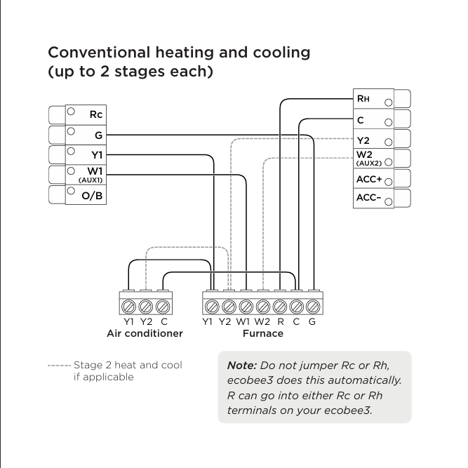
Conventional Heating and Cooling (Up to 2 Stages each)

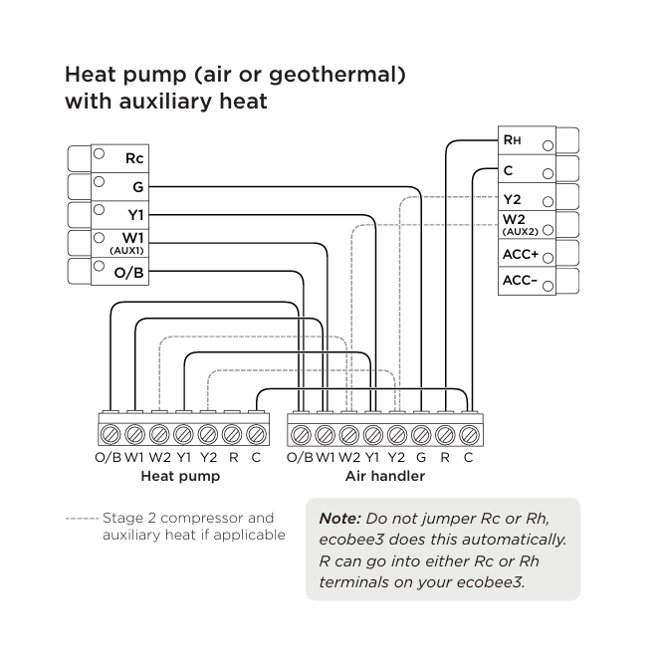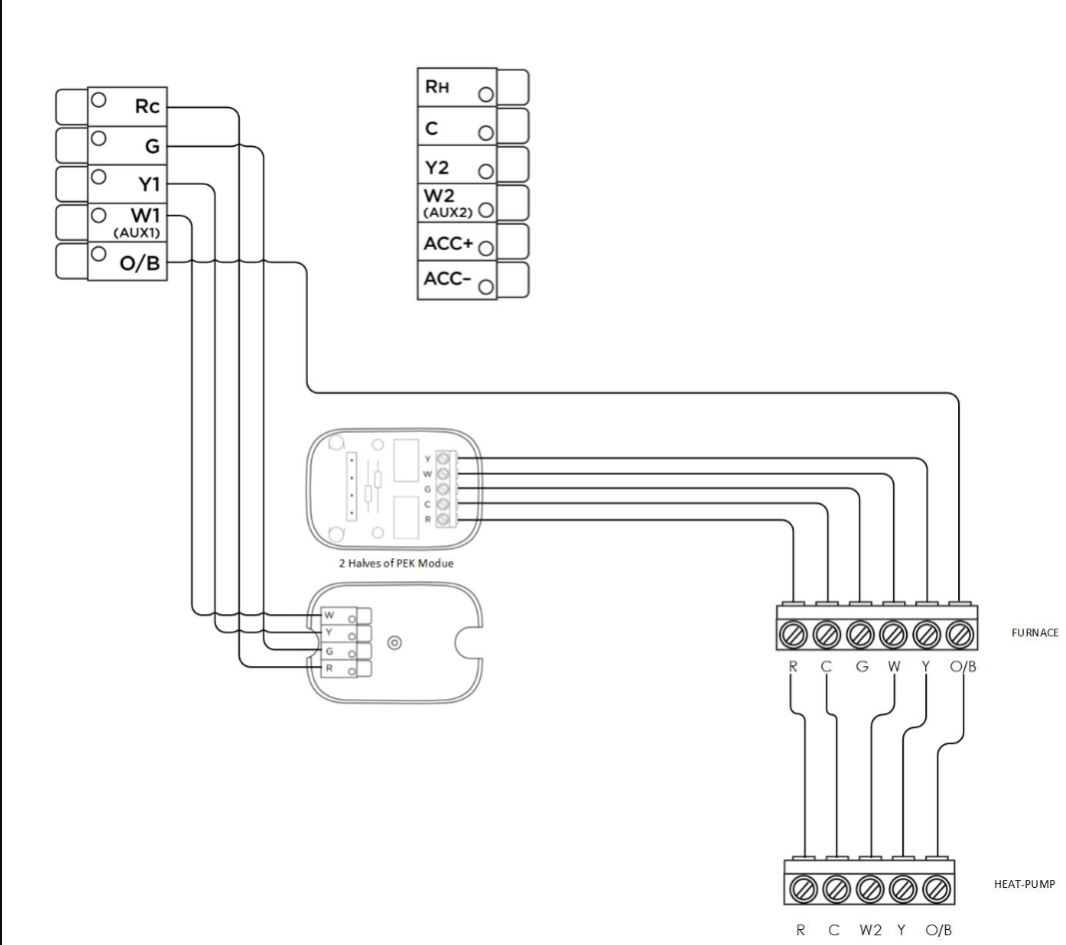
Heat Pump (air or geothermal) With Auxiliary Heat

Heat Pump with Auxiliary Heat and no C wire (Using PEK)

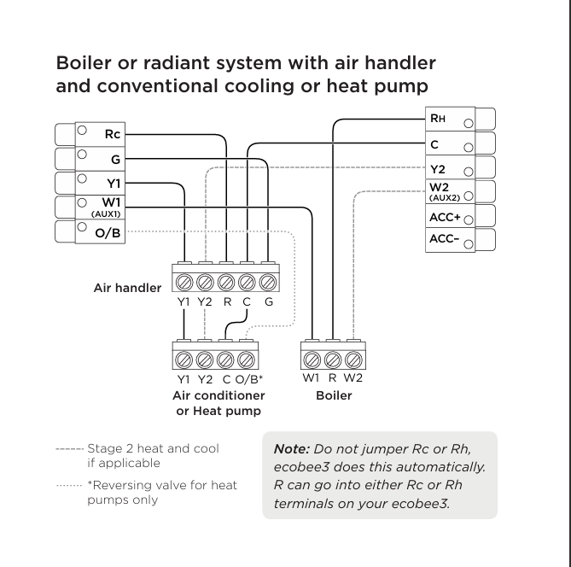
Boiler Radiant System

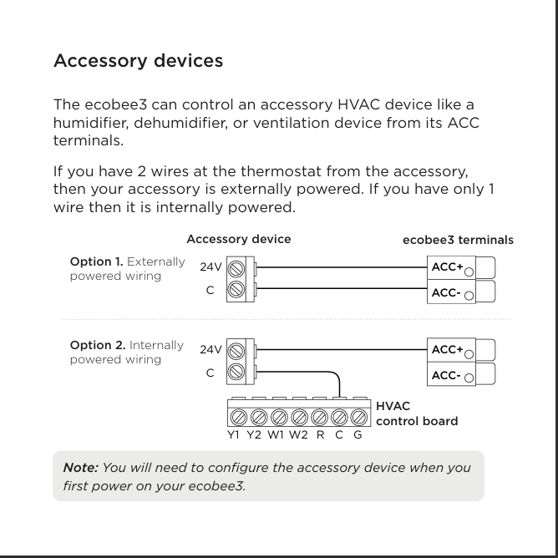
Accessory Devices

